DIY Hydraulic life project

Experiment Project procedures

-Requirements

1.Two syringes, small one and big one

2.cardboards or cups for put objects

3.a pipe for connect two syringes

4.A glue gun

My Experiment Project Video



Experiment Data & Calculation

W test=Fs=7MG

F1=9.5MG

F2=2MG

F1’=F1-F2=9.5-7=2.5MG

H1=8.5cm V1=25ml=25cm^3

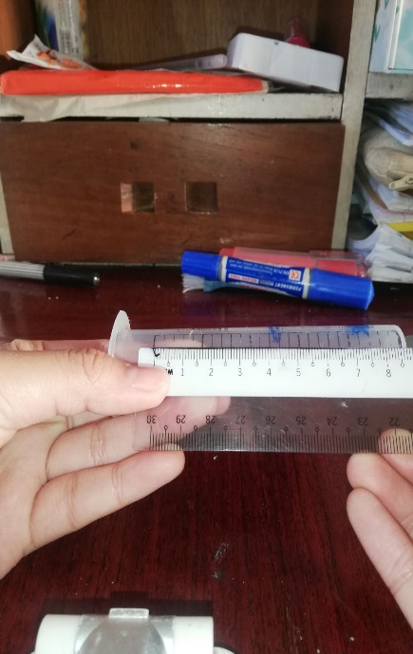

V1=A1xH1(the volume V of a prism or cylinder, where

A is the base area and h is the height)

25=A1x8.5

25/8.5=A1

A1=2.9 cm^2

H2=5cm

V2=6ml=6cm^3

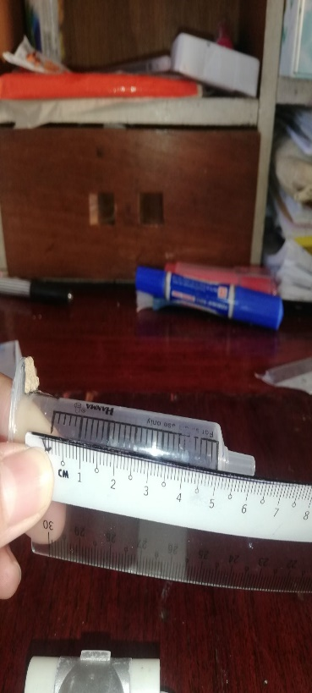

V2=A2xH2

6=A2x5

6/5=A2

A2=1.2 cm^2

P1=P2 / 0.4=0.8

F1’/A1=F2/A2

A2/A1=F2/F1

1.2/2.9=2MG/2.5MG

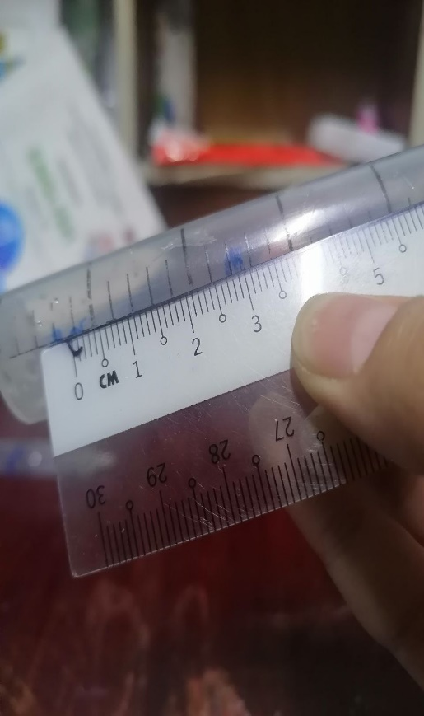 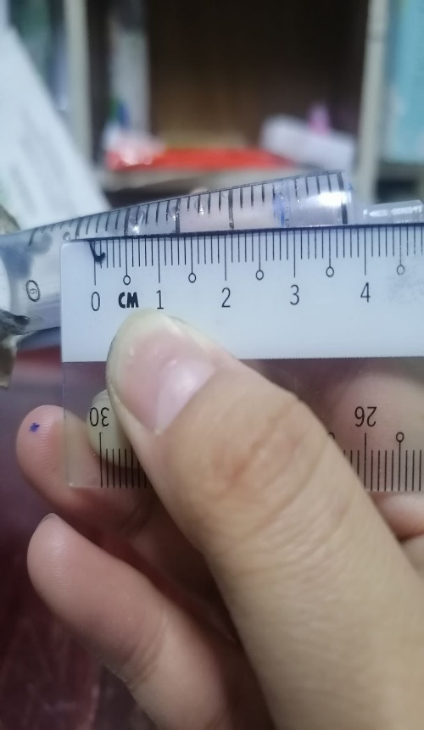The distance between The distance between before pressing before pressing and after pressing after pressing of small syringe

of Big syringe

distance after pressing

S1=3cm

S2=2.8cm

S2/S1=2.8/3=0.9 cm

The area, force are different 0.4.

The reason for the difference could be an error in the measurement.

The force and distance is different 0.1.

In the context of lifting a load using a hydraulic system, the work done (Work=Force × Distance) is relevant. The distance in this case is the height over which the force is applied.

If you increase the force applied and the height over which it is applied (distance), the work done will increase.

(Just my opinion)